Final Exam

CS 5700

Lixing Chen

**Questions:** 5

**Points Possible:** 130

For all questions, your answers must be based on what was taught in class this semester. Anything else will get you points deducted, up to and including zero credit. You must complete this exam individually.

**The expectation is that you show your work and complete these problems similar to how the sample final exam was done. Failure to do so will result in massive point deductions, up to and including receiving zero credit.**

Also, you must submit your exam only in one of the following file formats: DOCX or PDF. **Any other file format will result in an automatic 10 point deduction, and you will get zero credit if I am unable to open and read your file.** If you save your file in a different format and just change the file extension to docx or pdf, that is still not the proper format! You must either use a Microsoft program (such as Word) to save your file as DOCX, or you must convert your submission file to a PDF.

If you are writing out your answers, I recommend you give yourself about 15 minutes of buffer time to scan your exam and upload/submit it to Canvas. Otherwise, if typing in your answer, you should still give yourself enough time to save the document and upload/submit it to Canvas.

First question starts on the next page.

1. Using the example network given in the below figure, give the virtual circuit tables for all the switches after each of the following connections is established. Assume that the sequence of connections is cumulative; that is, the first connection is still up when the second connection is established, and so on. Also assume that the VCI assignment always picks the lowest unused VCI on each link, starting with 0, and that a VCI is consumed for both directions of a virtual circuit.



1. (10 points)

Host J connects to Host B

1. (10 points)

Host I connects to Host A

1. (10 points)

Host F connects to Host D

Fill out the below table with your answers, you can leave unused rows blank:

|  |  |  |  |  |  |
| --- | --- | --- | --- | --- | --- |
| **Question You’re Answering** | **Switch** | **Input Port** | **Input VCI** | **Output Port** | **Output VCI** |
| a | 3 | 1 | 0 | 3 | 0 |
| B | 3 | 2 | 0 | 0 | 0 |
| B | 2 | 0 | 0 | 3 | 0 |
| B | 1 | 1 | 0 | 2 | 0 |
| C | 4 | 2 | 0 | 3 | 0 |
| C | 2 | 1 | 0 | 3 | 1 |
| C | 1 | 1 | 1 | 0 | 0 |
| C |  |  |  |  |  |
|  |  |  |  |  |  |
|  |  |  |  |  |  |
|  |  |  |  |  |  |
|  |  |  |  |  |  |

For questions 2 and 3, refer to the following figure:

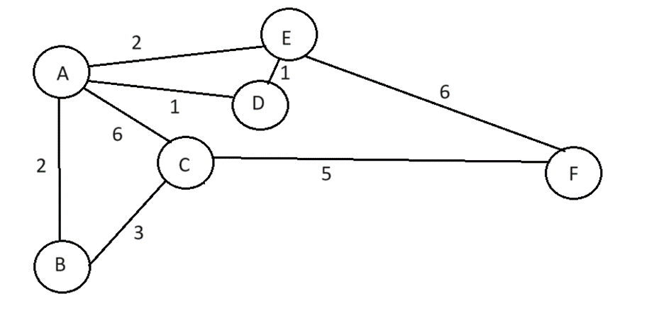

2. (40 points)

Give the datagram forwarding table for nodes A, C, D, and F. The links are labeled with relative costs; your tables should forward each packet via the lowest-cost path to its destination. If there is a tie in lowest-cost paths, break the tie with the path that has the least number of hops.

Node A:

Destination Next Hop

B B

C B

D D

E E

F E

Node C:

Destination Next Hop

A B

B B

D B

E B

F F

Node D:

Destination Next Hop

A A

B A

C A

E E

F E

Node F:

Destination Next Hop

A E

B C

C C

D E

E E

3. For the above figure, give global distance vector tables when:

1. (10 points)

Each node knows only the distances to its immediate neighbors. Fill out the following table as your answer:

|  |  |  |  |  |  |  |
| --- | --- | --- | --- | --- | --- | --- |
|  | **Distance to reach node** | | | | | |
| **Information stored at node** | **A** | **B** | **C** | **D** | **E** | **F** |
| **A** | 0 | 2 | 6 | 1 | 2 | Inf |
| **B** | 2 | 0 | 3 | Inf | Inf | Inf |
| **C** | 6 | 3 | 0 | Inf | Inf | 5 |
| **D** | 1 | Inf | Inf | 0 | 1 | Inf |
| **E** | 2 | Inf | Inf | 1 | 0 | 6 |
| **F** | Inf | Inf | 5 | Inf | 6 | 0 |

1. (10 points)

Each node has reported the information it had in the preceding step to its immediate neighbors. Fill out the following table as your answer:

|  |  |  |  |  |  |  |
| --- | --- | --- | --- | --- | --- | --- |
|  | **Distance to reach node** | | | | | |
| **Information stored at node** | **A** | **B** | **C** | **D** | **E** | **F** |
| **A** | 0 | 2 | 6 | 1 | 2 | 8 |
| **B** | 2 | 0 | 3 | 3 | 4 | 8 |
| **C** | 6 | 3 | 0 | 7 | 8 | 5 |
| **D** | 1 | 3 | 7 | 0 | 1 | 7 |
| **E** | 2 | 4 | 8 | 1 | 0 | 6 |
| **F** | 8 | 8 | 5 | 7 | 6 | 0 |

1. (10 points)

Step (b) happens a second time. Fill out the following table as your answer:

|  |  |  |  |  |  |  |
| --- | --- | --- | --- | --- | --- | --- |
|  | **Distance to reach node** | | | | | |
| **Information stored at node** | **A** | **B** | **C** | **D** | **E** | **F** |
| **A** | 0 | 2 | 6 | 1 | 2 | 8 |
| **B** | 2 | 0 | 3 | 3 | 4 | 8 |
| **C** | 6 | 3 | 0 | 7 | 8 | 5 |
| **D** | 1 | 3 | 7 | 0 | 1 | 7 |
| **E** | 2 | 4 | 8 | 1 | 0 | 6 |
| **F** | 8 | 8 | 5 | 7 | 6 | 0 |

4. (10 points)

Suppose a congestion-control scheme results in a collection of competing flows that achieve the following throughput rates:

200 KBps, 3 MBps, 400 KBps, 1 MBps, 8 MBps

Calculate the fairness index for this scheme. Show your work, otherwise, you will get zero credit.

Round your answer to two decimal places.

N = 5

Numerator = (200 + 3,000+ 400 + 1,000 + 8,000) ^ 2 = (12,600) ^ 2 = 158,760,000

Denominator = 5 * (200 ^ 2 + 3,000 ^ 2 + 400 ^ 2 + 1,000 ^ 2 + 8,000 ^ 2) = 371,000,000

F = 158,760,000 / 371,000,000 = 0.43

5. Suppose a router has three input flows and one output. It receives the packets listed in the below table all at about the same time, in the order listed, during a period in which the output port is busy but all queues are otherwise empty. Give the order in which the packets are transmitted, assuming

For parts a and b, show your work. Otherwise, you will get zero credit.

1. (10 points)

Fair queuing.

1. (10 points)

Weighted fair queuing, with flow 1 having weight 2, flow 2 having weight 3, and flow 3 having weight 8.

|  |  |  |
| --- | --- | --- |
| **Packet** | **Size** | **Flow** |
| 1 | 100 | 1 |
| 2 | 100 | 1 |
| 3 | 100 | 1 |
| 4 | 100 | 1 |
| 5 | 40 | 1 |
| 6 | 190 | 2 |
| 7 | 120 | 2 |
| 8 | 10 | 2 |
| 9 | 210 | 3 |
| 10 | 20 | 3 |

a:

Because all packets arrive all at about the same time,

Fi = max(Fi-1,Ai)+Pi

Flow 1:

Flow1_1 = max(0,0) + 100 = 100

Flow1_2 = max(100,0) + 100 = 200

Flow1_3 = max(200,0) + 100 = 300

Flow1_4 = max(300,0) + 100 = 400

Flow1_5 = max(400,0) + 40 = 440

Flow 2:

Flow2_6 = max(0,0) + 190 = 190

Flow2_7 = max(190,0) + 120 = 310

Flow2_8 = max(310,0) + 10 = 320

Flow 3:

Flow3_9 = max(0,0) + 210 = 210

Flow3_10 = max(210,0) + 20 = 230

Packet: 1,6,2,9,10,3,7,8,4,5

b:

Fi = max(Fi-1,Ai)+Pi /w

Flow 1:

Flow1_1 = max(0,0) + 100/2= 50

Flow1_2 = max(50,0) + 100/2 = 100

Flow1_3 = max(100,0) + 100 /2= 150

Flow1_4 = max(150,0) + 100/2 = 200

Flow1_5 = max(200,0) + 40/2 = 220

Flow 2:

Flow2_6 = max(0,0) + 190/3 = 63.33

Flow2_7 = max(63.33,0) + 120/3 = 103.33

Flow2_8 = max(103.33,0) + 10/3 = 106.67

Flow 3:

Flow3_9 = max(0,0) + 210/8 = 26.25

Flow3_10 = max(210,0) + 20/8 = 28.75

Packet: 9,10,1,6,2,7,8,3,4,5